
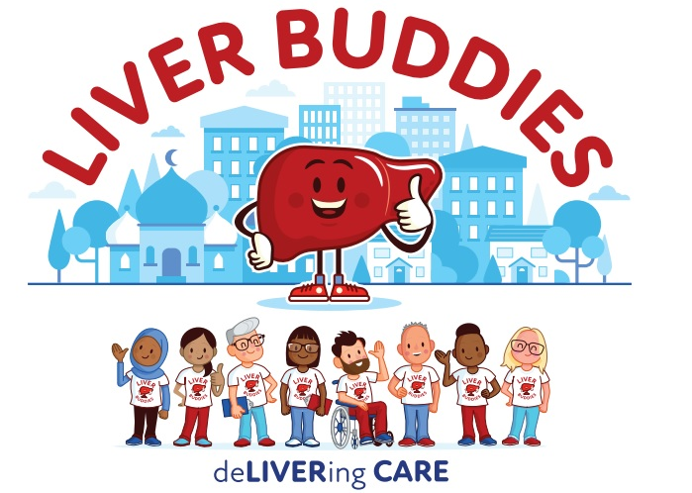


Join us at our Love Your Liver Roadshow

Date: Tuesday 7 July 2026
Time: 10am – 3:30pm (last scan)
Venue: Accu Stadium, Car Park B South, Stadium Way, Huddersfield HD1 6PG

What we do:

The Community Liver Health Checks Team are encouraging members of the public to get their liver checked for free in our mobile clinic vehicle. The event offers individuals an opportunity to prioritise their liver health by gaining valuable information about various types of liver disease and how to improve their liver health.

Liver Scan Criteria:
To be eligible for a free liver scan, you must have one or more conditions from the list below:

- You may have previously had or been at risk of Hepatitis B or C
- You consume more than 14 units of alcohol a week
- You are 50 years old and over with Type 2 diabetes
- You are 50 years old and over with a body mass index of >30 BMI or >27 BMI for some people depending on your ethnic background

You will be asked these questions prior to being offered a scan of your liver by the CLHC team. If you have had a liver scan in the last 12 months you will not be eligible.


For more information email: leedsth-tr.wylivercareodn@nhs.net
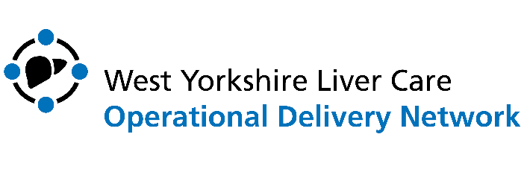

Visit our website at: https://www.westyorkshirelivercareodn.nhs.uk/

